Eukaryotic and Prokaryotic Cells
- Draw a simple animal cell and a simple plant cell and add the following labels to your eukaryotic cells (where necessary):
- Nucleus
- Cell membrane
- Mitochondria
- Ribosomes
- Cell wall
- Chloroplasts
- Cytoplasm
- Permanent vacuole

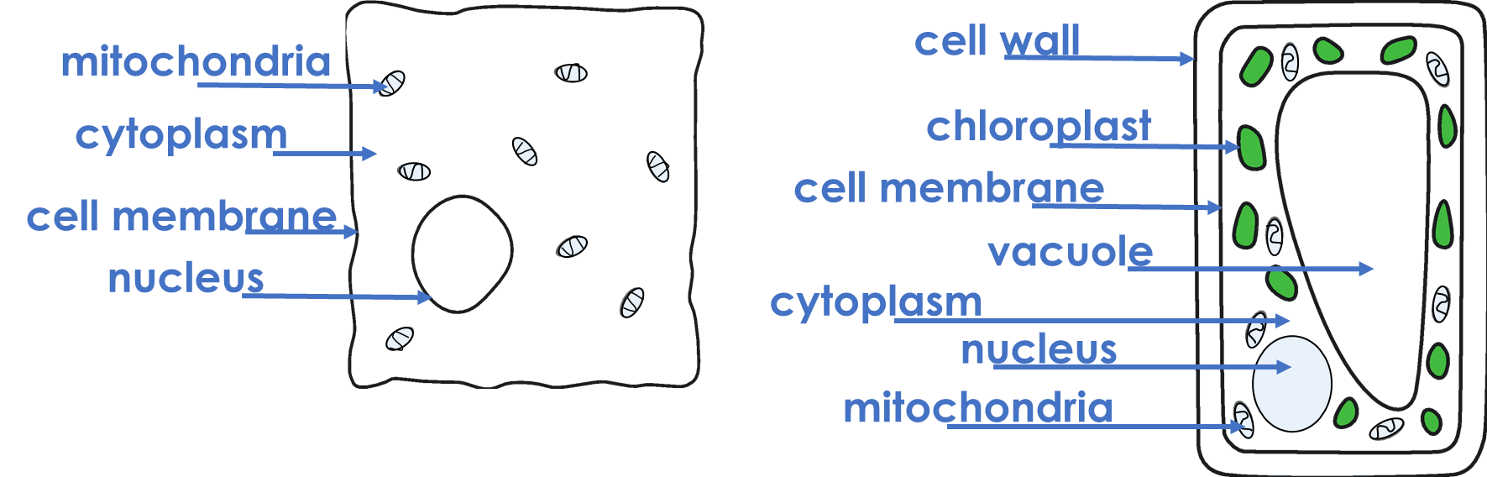

- Use your previous knowledge and information about each feature to help you label this prokaryotic bacterial cell:

Genetic material – in the form of a loop of DNA not found in a nucleus
Cytoplasm – jelly-like substance where chemical reactions occur
Flagella – whip-like structures that allow the bacteria to move around
Cell wall – provides structure and support to the cell
Capsule – slimy outer layer that provides protection to the cell
Cell membrane – controls the entry and exit of substances to and from the cell
Plasmid – small ring of DNA
Ribosome – very small organelle that carries out protein synthesis

Ribosome

Cytoplasm

Genetic material
Cell membrane

Plasmid
Cell wall

Capsule

Flagella

- Place ticks in the correct boxes to summarise the features that are found in each type of cell.
Feature | Animal Cell | Plant Cell | Bacterial Cell
Nucleus | ✓ | ✓
Plasmids |  |  | ✓
Cell membrane | ✓ | ✓ | ✓
Cell wall |  | ✓ | ✓
Chloroplasts |  | ✓
Cytoplasm | ✓ | ✓ | ✓
Permanent vacuole |  | ✓
Flagella |  |  | ✓

Stretch Activity

The image below shows a Euglena cell. Euglena is a unicellular organism. Decide if it is a prokaryotic or eukaryotic cell based on its features and explain your decision.

Although Euglena possesses a flagellum, which is generally a feature of prokaryotic cells, it has a nucleus so must qualify as a eukaryotic cell. It falls under the genus of single cell flagellate eukaryotes.

